**PRACTICAL No. 1**

**Aim:** 2D Linear Convolution, Circular Convolution between two 2D matrices.

**2D Linear Convolution**

**Example 1:**

**Code:**

clc;

x=[4,5,6;7,8,9];

h=[1;1;1];

disp(x,"x=");

disp(h,"h=");

y=conv2(x,h);

disp(y, '2D Linear Convolution result: y =' );

**Output:**

x=

4. 5. 6.

7. 8. 9.

h=

1.

1.

1.

2D Linear Convolution result: y =

4. 5. 6.

11. 13. 15.

11. 13. 15.

7. 8. 9.

**Example 2:**

**Code:**

clc;

x=[1,2,3;4,5,6;7,8,9];

h=[1,1;1,1;1,1];

disp(x,"x=");

disp(h,"h=");

y=conv2(x,h);

disp(y, '2D Linear Convolution result: y =' );

**Output:**

x=

1. 2. 3.

4. 5. 6.

7. 8. 9.

h=

1. 1.

1. 1.

1. 1.

2D Linear Convolution result: y =

1. 3. 5. 3.

5. 12. 16. 9.

12. 27. 33. 18.

11. 24. 28. 15.

7. 15. 17. 9.

**2D Circular Convolution**

**Example 1:**

**Code:**

clc ;

x=[1,2;3,4];

h=[5,6;7,8];

disp(x,'x=');

disp(h,'h=');

X=fft2(x);

H=fft2(h);

Y=X.*H;

y=ifft(Y);

disp(y, '2D Circular Correlation Result: y =' );

**Output:**

x=

1. 2.

3. 4.

h=

5. 6.

7. 8.

2D Circular Correlation Result: y =

70. 68.

62. 60.

**Example 2:**

**Code:**

clc ;

x=[1,2,3;4,5,6;7,8,9];

h=[1,1,1;1,1,1;1,1,1];

disp(x,'x=');

disp(h,'h=');

X=fft2(x);

H=fft2(h);

Y=X.*H;

y=ifft(Y);

disp(y, '2D Circular Correlation Result: y =' );

**Output:**

x=

1. 2. 3.

4. 5. 6.

7. 8. 9.

h=

1. 1. 1.

1. 1. 1.

1. 1. 1.

2D Circular Correlation Result: y =

45. 45. 45.

45. 45. 45.

45. 45. 45.

**PRACTICAL No. 2**

**Aim:** Circular Convolution expressed as Linear Convolution plus alias.

**Code:**

clc ;

x =[1,2;3,4];

h=[5,6;7,8];

y=conv2(x,h);

y1=[y(:,1)+y(:,$),y(:,2) ];

y2=[y1(1,:)+y1($,:);y1(2,:)];

disp(y, 'Linear Convolution Result: y=');

disp(y2 , 'Circular Convolution expressed as Linear Convolution =' );

**Output:**

Linear Convolution Result: y=

5. 16. 12.

22. 60. 40.

21. 52. 32.

Circular Convolution expressed as Linear Convolution =

70. 68.

62. 60.

**PRACTICAL No. 3**

**Aim:** Linear Cross correlation of a 2D matrix, Circular correlation between two signals and Linear auto correlation of a 2D matrix, Linear Cross correlation of a 2D matrix

**A] Linear Cross correlation of a 2D matrix**

**Code:**

clc;

x = [3,1;2,4];

h1 = [1,5;2,3];

h2 = h1(:,$:-1:1);

h = h2($:-1:1,:);

y = conv2(x,h)

disp(y, 'Linear cross Correlation result y=')

**Output:**

Linear cross Correlation result y=

9. 9. 2.

21. 24. 9.

10. 22. 4.

**B] Circular correlation between two signals**

**Code:**

clc;

x = [1,5;2,4];

h = [3,2;4,1];

h = h(:,$:-1:1);

h = h($:-1:1,:);

X = fft2(x);

H = fft2(h);

Y = X.*H;

y = ifft(Y);

disp(y,'Circular Correlation result y=')

**Output:**

Circular Correlation result y=

37. 23.

35. 25.

**C] Linear autocorrelation of a 2D matrix**

**Code:**

clc;

x1 = [1,1;1,1];

x2 = x1(:,$:-1:1);

x2 = x2($:-1:1,:);

x = conv2(x1,x2)

disp(x,'Linear autoCorrelation result x=')

**Output:**

Linear autoCorrelation result x=

1. 2. 1.

2. 4. 2.

1. 2. 1.

**D] Linear Cross correlation of a 2D matrix**

**Code:**

clc;

x = [1,1;1,1];

h1 = [1,2;3,4];

h2 = h1(:,$:-1:1);

h = h2($:-1:1,:);

y = conv2(x,h)

disp(y, ' Linear cross Correlation result y=')

**Output:**

Linear cross Correlation result y=

4. 7. 3.

6. 10. 4.

2. 3. 1.

**PRACTICAL No. 4**

**Aim:** Perform DFT of a 4x4 gray scale image.

**Code:**

clc;

x=[1,1,1,1;1,1,1,1;1,1,1,1;1,1,1,1];

X=fft(x,-1);

disp(X,"X[k]=");

**Output:**

X[k]=

16. 0. 0. 0.

0. 0. 0. 0.

0. 0. 0. 0.

0. 0. 0. 0.

**PRACTICAL No. 5**

**AIM:- Compute discrete cosine transform, Program to perform KL transform for the given 2D matrix.**

**Code:-**

clear;

clc;

X=[4,3,5,6;4,2,7,7;5,5,6,7];

[m,n]=size(X);

A=[];

E=[];

for i=1:n

A=A+X(:,i);

E=E+X(:,i)*X(:,i)';

end

mx=A/n;

E=E/n;

C=E-mx*mx';

[V,D]=spec(C);

d=diag(D);

[d,i]=gsort(d);

for j=1:length(d)

T(:,j)=V(:,i(j));

end

T=T'

disp(d,' Eigen Values are U = ')

disp(T,'The eigen vector matrix T =')

disp(T,'The KL tranform basis is =')

for i=1:n

Y(:,i)=T*X(:,i);

end

disp(Y,'KL transformation of the input matrix Y =')

for i=1:n

x(:,i)=T'*Y(:,i);

end

disp(x,'Reconstruct matrix of the given sample matrix X =')

**Output:-**

Eigen Values are U =

6.1963372

0.2147417

0.0264211

The eigen vector matrix T =

0.4384533 0.8471005 0.3002988

0.4460381 - 0.4951684 0.7455591 - 0.7802620 0.1929481 0.5949473

The KL tranform basis is =

0.4384533 0.8471005 0.3002988

0.4460381 - 0.4951684 0.7455591 - 0.7802620 0.1929481 0.5949473

KL transformation of the input matrix Y = 6.6437095 4.5110551 9.9237632 10.662515 3.5312743 4.0755729 3.2373664 4.4289635 0.6254808 1.0198466 1.0190104 0.8336957

Reconstruct matrix of the given sample matrix X = 4. 3. 5. 6.

4. 2. 7. 7.

5. 5. 6. 7.

**PRACTICAL No. 6**

**AIM:- Brightness enhancement of an image, Contrast Manipulation, image negative.**

Install Image Processing and Signal Processing packages and restart scilab. Run this command on console: atomsRemove('scicv')

Restart scilab

And run code

**Brightness Enhancement**

Code:-

Clc;

close;

a=imread('C:\Users\ADMIN\Desktop\flower.jpg');

a=rgb2gray(a);

b=double(a)+50;

b=uint8(b);

figure(1);

imshow(a);

title("Original Image")

figure(2);

imshow(b);

title("Enhanced Image")

**Output:-**

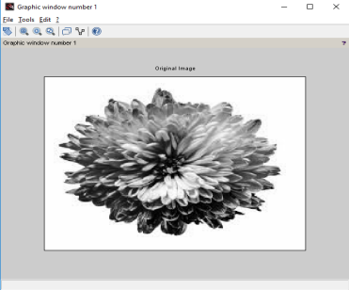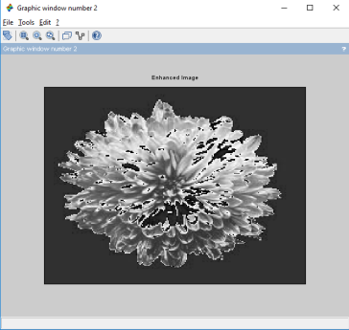

**Contrast Manipulation**

clc ;

close ;

a = imread('C:\Users\ADMIN\Desktop\flower.jpg');

a = rgb2gray(a);

b = double(a)*0.5;

b = uint8 (b)

c = double(b)*2;

c = uint8(c)

figure(1)

imshow(a);

title('Original Image')

figure(2)

imshow(b);

title('Decreased Contrast' )

figure(3)

imshow(c);

title('Increased Contrast')

**Output:-**

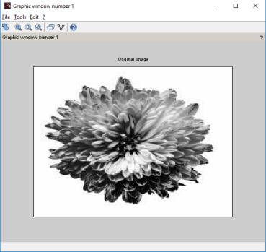

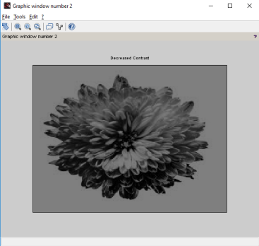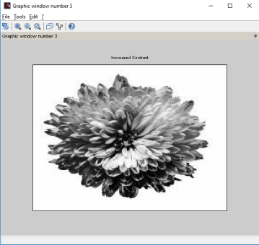

**Image Negative**

Code:-

clc;

close;

a = imread('C:\Users\ADMIN\Desktop\flower.jpg');

k = 255-double(a);

k = uint8(k);

figure(1)

imshow(a);

title('Original Image')

figure(2)

imshow(k);

title('Negative of Original Image')

**Output:**

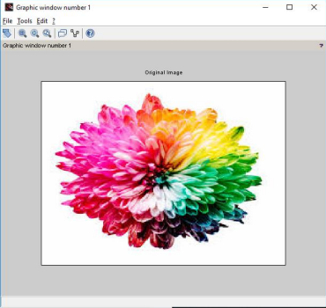

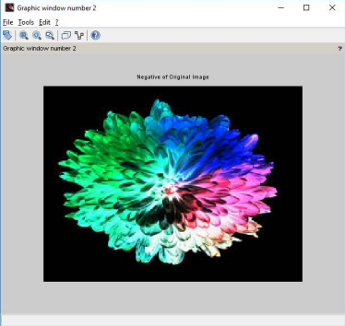

**PRACTICAL No. 7**

**AIM:- Perform threshold operation, perform gray level slicing without background.**

Install Image Processing and Signal Processing packages and restart scilab. Run this command on console: atomsRemove('scicv')

Restart scilab

And run code

**Threshold Operation Code:-**

clc;

close;

a = imread('C:\Users\ADMIN\Desktop\flower.jpg');

a = rgb2gray(a);

[m n] = size(a);

t = input('Enter threshold parameter: ');

for i = 1:m

for j = 1:n

if(a(i,j)<t)

b(i,j)=0;

else

b(i,j) =255;

end

end

end

figure(1)

imshow(a);

title('Original Image')

figure(2)

imshow(b);

title('Threshold Image')

xlabel(sprintf('Threshold Value is %g ',t))

**Output:**

**Enter threshold parameter: 140**

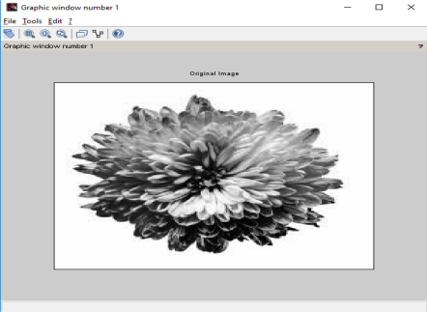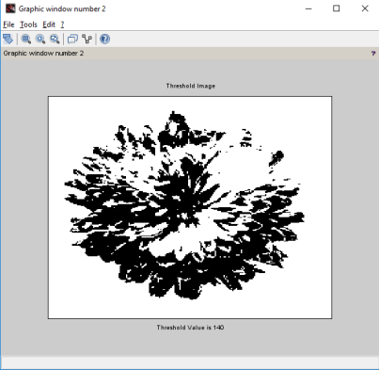

**Gray Level Scaling without background. Code:-**

clc ;

x = imread('C:\Users\ADMIN\Desktop\flower.jpg'); x = rgb2gray(x);

y = double(x);

[m,n]= size(y);

L = max(max(x));

a = round(L/2) ;

b = L;

for i =1: m

for j =1: n

if(y(i,j)>=a & y(i,j)<=b)

z(i,j) = L;

else

z(i,j)=0;

end

end

end

z = uint8(z);

figure(1)

imshow(x);

title('Original Image')

figure(2)

imshow(z);

title('Gray Level Slicing without preserving background')

**Output**

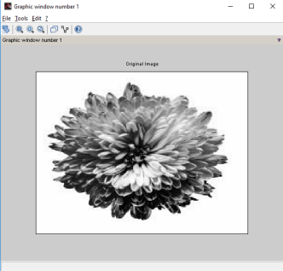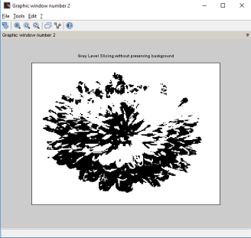

**PRACTICAL No. 8**

**AIM:- Image Segmentation.**

Install Image Processing and Signal Processing packages and restart scilab. Run this command on console: atomsRemove('scicv')

Restart scilab

And run code

**(a)** Differentiation of Gaussian function.

clc ;

close ;

sigma = input('Enter the value of sigma: ')

i = -10:.1:10;

j = -10:.1:10;

r = sqrt(i.*i+j.*j);

y = (1/(sigma^2))*(((r.*r)/sigma^2)-1) .* exp(-r.*r/2*sigma^2);

plot(i,y)

legend(sprintf('The sigma value is %g',sigma))

xtitle('Differentiation of Gaussian function')

**Output:-**

**Enter the value of sigma: 1**

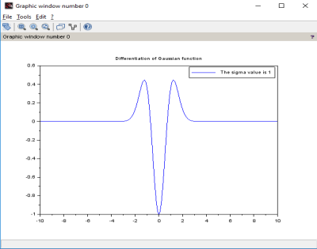

clc ;

**(b)** Differentiation of Gaussian Filter 1

**Output:**

**Enter the value of sigma1: 4**

**Enter the value of sigma2: 1**

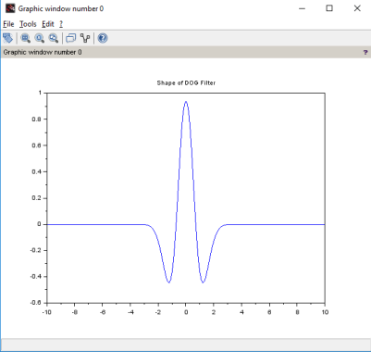

**(c)** Edge Detection using Different Edge detectors

close ;

clc ;

a = imread('C:\Users\ADMIN\Desktop\flower.jpg'); a = rgb2gray(a);

c = edge(a,'sobel');

d = edge(a,'prewitt');

e = edge(a,'log');

f = edge (a,'canny');

imshow(a)

title('Original Image')

figure

imshow(c)

title('Sobel')

figure

imshow(d)

title('prewitt')

figure

imshow(e)

title('Log')

figure

imshow(f)

title(‘Canny’)

PRACTICAL No. 1

Aim: 2D Linear Convolution, Circular Convolution between two 2D matrices.

2D Linear Convolution

Example 1:

Code:

clc;

x=[4,5,6;7,8,9];

h=[1;1;1];

disp(x,"x=");

disp(h,"h=");

y=conv2(x,h);

disp(y, '2D Linear Convolution result: y =' );

Output:

x=

4. 5. 6.

7. 8. 9.

h=

1.

1.

1.

2D Linear Convolution result: y =

4. 5. 6.

11. 13. 15.

11. 13. 15.

7. 8. 9.

Example 2:

Code:

clc;

x=[1,2,3;4,5,6;7,8,9];

h=[1,1;1,1;1,1];

disp(x,"x=");

disp(h,"h=");

y=conv2(x,h);

disp(y, '2D Linear Convolution result: y =' );

Output:

x=

1. 2. 3.

4. 5. 6.

7. 8. 9.

h=

1. 1.

1. 1.

1. 1.

2D Linear Convolution result: y =

1. 3. 5. 3.

5. 12. 16. 9.

12. 27. 33. 18.

11. 24. 28. 15.

7. 15. 17. 9.

2D Circular Convolution

Example 1:

Code:

clc ;

x=[1,2;3,4];

h=[5,6;7,8];

disp(x,'x=');

disp(h,'h=');

X=fft2(x);

H=fft2(h);

Y=X.*H;

y=ifft(Y);

disp(y, '2D Circular Correlation Result: y =' );

Output:

x=

1. 2.

3. 4.

h=

5. 6.

7. 8.

2D Circular Correlation Result: y =

70. 68.

62. 60.

Example 2:

Code:

clc ;

x=[1,2,3;4,5,6;7,8,9];

h=[1,1,1;1,1,1;1,1,1];

disp(x,'x=');

disp(h,'h=');

X=fft2(x);

H=fft2(h);

Y=X.*H;

y=ifft(Y);

disp(y, '2D Circular Correlation Result: y =' );

Output:

x=

1. 2. 3.

4. 5. 6.

7. 8. 9.

h=

1. 1. 1.

1. 1. 1.

1. 1. 1.

2D Circular Correlation Result: y =

45. 45. 45.

45. 45. 45.

45. 45. 45.

figure

imshow(f)

title('Canny')

**Output:**

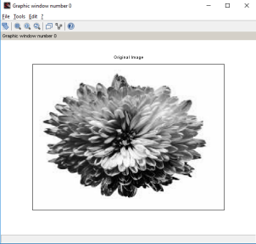

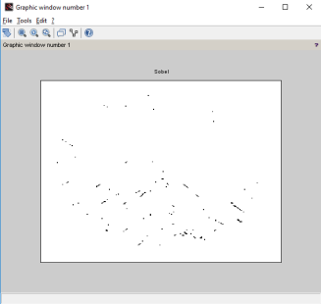





**PRACTICAL No. 9**

**AIM:- Image Compression.**

Install Image Processing and Signal Processing packages and restart scilab. Run this command on console: atomsRemove('scicv')

Restart scilab

And run code

**(a)** Block Truncation Coding BTC (Output in the form of Matrix). **Code:-**

close;

clear;

clc;

x=[65,75,80,70;72,75,82,68;84,72,62,65;66,68,72,80];

disp(x,"Original Block is x = " );

[ m1 n1 ] = size(x);

blk = input("Enter the block size: ");

for i = 1:blk:m1

for j = 1:blk:n1

y = x(i:i+(blk-1),j:j+(blk -1));

m = mean(mean(y));

disp(m,"mean value is m = ");

sig = stdev(y);

disp(sig,"Standard deviation of the block is = ");

b = y>m;

disp(b,"Binary allocation matrix is B= ");

K = sum(sum(b));

disp(K,"number of ones = ");

if(K~=blk^2)&( K~=0)

ml = m-sig*sqrt(K/((blk^2)-K));

disp(ml,"The value of a = ");

mu = m+sig*sqrt(((blk^2)-K)/K);

disp(mu,"The value of b = ");

x(i:i+(blk-1),j:j+(blk-1))=b*mu+(1-b)*ml;

end

end

end

disp(round(x),"Reconstructed Block is x = " );

**Output :**

**Original Block is x =**

**65. 75. 80. 70.**

**72. 75. 82. 68.**

**84. 72. 62. 65.**

**66. 68. 72. 80.**

**Enter the block size: 4**

**mean value is m =**

**72.25**

**Standard deviation of the block is = 6.6282225**

**Binary allocation matrix is B=**

**F T T F**

**F T T F**

**T F F F**

**F F F T**

**number of ones =**

**6.**

**The value of a =**

**67.115801**

**The value of b =**

**80.806998**

**Reconstructed Block is x =**

**67. 81. 81. 67.**

**67. 81. 81. 67.**

**81. 67. 67. 67.**

**67. 67. 67. 81.**

**PRACTICAL No. 10**

**AIM:- Binary Image Processing and Colour Image processing.**

Install Image Processing and Signal Processing packages and restart scilab. Run this command on console: atomsRemove('scicv')

Restart scilab

And run code

(a) Dilation and erosion process.

**Code:-**

close ;

clear ;

clc ;

a = imread('C:\Users\ADMIN\Desktop\letter.png');

b = imcreatese('rect',7,7); *//Structuring element value can be either rect, ellipse, cross* a1 = imdilate(a,b);

a2 = imerode(a,b);

figure(1)

imshow(a);

title('Original Image')

figure(2)

imshow(a1);

title('Dilated Image')

figure(3)

imshow(a2);

title('Eroded Image')

**Output:-**



**(b)** opening and closing operation on the image.

Code:-

close ;

clear ;

clc ;

a = imread('C:\Users\ADMIN\Desktop\letter.png');

b = imcreatese('rect',7,7); *//Structuring element value can be either rect, ellipse, cross* a1 = imopen(a,b);

a2 = imclose(a,b);

figure(1)

imshow(a);

title('Original Image')

figure(2)

imshow(a1);

title('Opening Operation')

figure(3)

imshow(a2);

title('Closing Operation')

**Output:-**





(c) Read an RGB image and extract the three colour components red, green and blue. Code:-

clc;

close ;

RGB = imread('C:\Users\ADMIN\Desktop\flower.jpg');

R = RGB;

G = RGB;

B = RGB;

R(: ,: ,2) =0;

R(: ,: ,3) =0;

G(: ,: ,1) =0;

G(: ,: ,3) =0;

B(: ,: ,1) =0;

B(: ,: ,2) =0;

figure(1)

imshow(RGB);

title('Original Color Image');

figure(2)

imshow(R);

title('Red Component');

figure(3)

imshow(G);

title('Green Component');

figure(4)

imshow(B);

title('Blue Component')

**Output:-**







(d) Read a Colour image and separate the colour image into red green and blue planes.

Code:-

clc;

close ;

RGB = imread('C:\Users\ADMIN\Desktop\flower.jpg');

R = RGB;

G = RGB;

B = RGB;

R(: ,: ,1) =0;

G(: ,: ,2) =0;

B(: ,: ,3) =0;

figure(1)

imshow(RGB);

title('Original Color Image');

figure(2)

imshow(R);

title('Red Component Missing');

figure(3)

imshow(G);

title('Green Component Missing');

figure(4)

imshow(B);

title('Blue Component Missing')

Output:-



